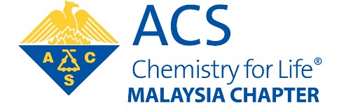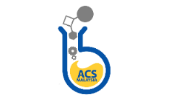

ACTIVITY PROPOSAL

Name of Event
Date of Event
Place of Event
Event organizer/s
Strategic objective
(choose one)
Please briefly explain how the event would engage ACS members.
Please briefly explain how the event assists chapter visibility.
Please mention if the event will provide platform for income re-generation and can be sustained in the future.

Please list any specific assistance and needs required from the central committee.

Please email the proposal to the person in charge according to the strategic objectives below:
Advance member professional career (in-house event): hllee@usm.my, firdaus@fbb.utm.my
Award for conference & seminar: WG Chair Award: Dr. Mohamed Ibrahim (ibra@upm.edu.my)
Improve education (i.e. open seminar, conference, workshop): WG Chair Education: Dr. Nurul Huda Abdul Karim (nurulhuda@ukm.edu.my)
Communicate chemistry’s value (i.e. outreach, festival): WG Chair Outreach: Associate Prof. Dr. Eric Chan (chanwc@ucsiuniversity.edu.my)

