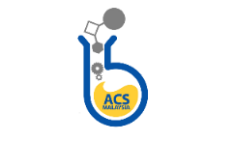

ACTIVITY PROPOSAL

Name of Event
Date of Event
Place of Event
State Event Organizer/s and Specific Collaboration  (please include member’s name and contact details)  *if applicable |  Organized by:   *Jointly organized by:   *Co-organized by:   *Sponsored by:   *Supported by IAC/Grants:   *Supported by:
Strategic Objective/s  (tick all that apply) |  Provide Information Solutions   Empower Members and Member Communities   Support Excellence in Education   Communicate Chemistry's Value   Embrace and Advance Inclusion in Chemistry
Task Force Group  (tick only one) |  Public Relations   Capacity Development   Outreach   Award
Please briefly explain how the event would engage Chapter members.
Please briefly explain how the event assists the Chapter’s visibility.
Please mention if the event will provide a platform for income re-generation and can be sustained in the future.
Please list any specific assistance and needs to be required from the central committee.
Financial Budget

Please email the proposal to acsmalaysiachapter@gmail.com
For the Chapter’s committee use only
Activity proposal approved? | Yes/No
Approval date

